Image | 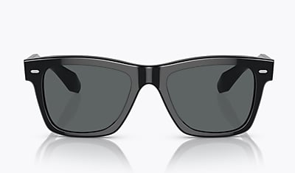
Brand | OLIVER PEOPLES
Model Name | N.04 SUN
Price | RS 6550
PRODUCT DETAILS

